Project Design Phase-II

Data Flow Diagram & User Stories

|  |  |
| --- | --- |
| Date | 20 November 2022 |
| Team ID | PNT2022TMID52418 |
| Project Name | AI-based localization and classification of skin disease with erythema |
| Maximum Marks | 4 Marks |

# Data Flow Diagrams:

A Data Flow Diagram (DFD) is a traditional visual representation of the information flows within a system. A neat and clear DFD can depict the right amount of the system requirement graphically. It shows how data enters and leaves the system, what changes the information, and where data is stored.

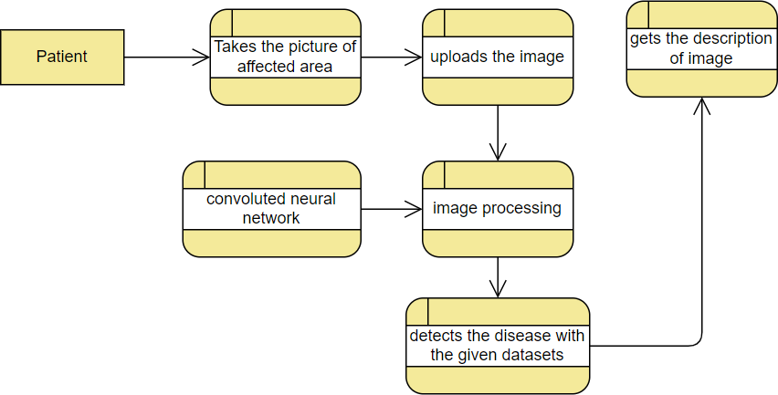

# :

**User Stories**

Use the below template to list all the user stories for the product.

|  |  |  |  |  |  |  |
| --- | --- | --- | --- | --- | --- | --- |
| **User Type** | **Functional Requirement (Epic)** | **User Story Number** | **User Story / Task** | **Acceptance criteria** | **Priority** | **Release** |
| Customer | Registration | USN-1 | As a user, I can register for the application by entering my email, password, and confirming  my password. | I can access my account / dashboard | High | Sprint-1 |
|  | Confirmation | USN-2 | As a user, I will receive confirmation email once I have registered for the application | I can receive confirmation email & click confirm | High | Sprint-1 |
|  | Login | USN-3 | As a user, I can login for the application  through Gmail | I can access my account /  dashboard | Medium | Sprint-1 |
|  | Login | USN-4 | As a user, I can log into the application by entering email & password | I can access my account / dashboard | High | Sprint-1 |
|  | Dashboard | USN-5 | As a user, I can see the my profile, medical history, upload image , getting report services  provided by the application | I can get into one of the services and use it | Medium | Sprint-2 |
|  | Data input | USN-6 | As a user, I can upload the images of the affected skin area | I can submit it to the application | High | Sprint-2 |
| Administrator | Train model | USN-7 | As a administrator , I can train a model to compare the images uploaded with the  images in the database to detect the disease | I can test the model whether it meets the  criteria | High | Sprint-3 |
| Trained model | Image processing | USN-8 | By comparing the images the disease will be detected with the given datasets | All the necessary operation performed and information extracted | High | Sprint-3 |
|  | Report generation | USN-9 | Based on the detection of disease, report generated | The results will be shown on the screen to the  patients | High | Sprint-4 |